Project Road Map

Intelligent Urban Mobility Analytics Using GPS & Traffic Data
Domain: Urban Mobility Analytics

Problem Statement
Develop an analytics platform integrating GPS, traffic, weather and accident data to visualize traffic, predict congestion and recommend routes.

Objectives
Track vehicles, visualize maps, analyze traffic, predict congestion, identify accident hotspots, generate reports.

Datasets
- Geo Life GPS Trajectories
https://www.microsoft.com/en-us/download/details.aspx?id=52367&utm_source=chatgpt.com

- Metro Interstate Traffic Volume
https://www.kaggle.com/datasets/boltzmannbrain/nab?utm_source=chatgpt.com

- India Road Accident Dataset
https://www.kaggle.com/datasets/khushikyad001/india-road-accident-dataset-predictive-analysis
- Historical Weather Dataset
https://www.kaggle.com/datasets/muthuj7/weather-dataset?utm_source=chatgpt.com

Abstract
Urban transportation systems are facing significant challenges due to rapid urbanization, increasing vehicle density, traffic congestion, road accidents, unpredictable weather conditions, and inefficient traffic management. These issues lead to longer travel times, increased fuel consumption, environmental pollution, and reduced road safety, making efficient urban mobility management a critical requirement for smart cities.
Existing transportation systems primarily focus on navigation and route guidance but often provide limited support for integrated traffic analytics, weather impact analysis, and accident risk assessment. Current solutions lack comprehensive data-driven insights that combine GPS trajectory data, weather conditions, and accident information to support intelligent decision-making for urban mobility.
To address these challenges, this project proposes an Intelligent Urban Mobility Analytics Using GPS & Traffic Data platform by integrating GeoLife GPS Trajectories, Weather History, and Road Accident Prediction datasets. The project follows a systematic workflow including data collection, preprocessing, exploratory data analysis, feature engineering, and machine learning. Prediction models such as Decision Tree, Random Forest, XGBoost, and Logistic Regression are employed to analyze mobility patterns and predict accident risks. The analytical results are presented through an interactive dashboard using maps, charts, heatmaps, and reports for effective visualization.
The proposed system can be further extended by incorporating real-time GPS data, IoT sensors, live traffic information, cloud deployment, smart route recommendation, traffic signal optimization, and mobile application support. These enhancements will transform the system into a scalable Smart Urban Mobility Analytics Platform capable of supporting intelligent transportation systems and future smart city initiatives.

Workflow
Data Collection
↓
Data Cleaning
↓
Data Integration
↓
Exploratory Data Analysis (12 Techniques)
↓
Preprocessing
↓
Feature Engineering
↓
Machine Learning Models
↓
Model Explainability (SHAP & LIME)
↓
Model Evaluation
↓
Comparative Analysis
↓
Interactive Dashboard
↓
Reports & Smart Insights

Preprocessing
- Missing Value Handling
- Duplicate Removal
- GPS Coordinate Validation
- Date & Time Formatting
- Label Encoding
- One-Hot Encoding
- Feature Scaling
- Normalization
- Standardization
- Outlier Detection
- Data Integration
- Train-Test Split

Feature Engineering
Create new features such as
- Average Speed
- Travel Distance
- Travel Time
- Peak Hour Indicator
- Congestion Index
- Weather Severity Index
- Accident Risk Score
- Road Density
- Route Frequency
- Weekend Indicator

Machine Learning Models

Classification
- Decision Tree
- Random Forest
- XGBoost
- CatBoost
- Logistic Regression

Visualization
- Line Chart
- Bar Chart
- Pie Chart
- Histogram
- Boxplot
- Scatter Plot
- Correlation Heatmap
- GPS Route Map
- Traffic Heatmap
- Accident Heatmap
- Feature Importance Plot
- Interactive Dashboard

Future Enhancements
Weather Integration, Parking Analytics, Public Transport Analytics, Mobile App, Cloud Deployment, Chatbot

Tech Stack
Frontend: React.js
Backend: Node.js + Express.js
Database: PostgreSQL/MySQL
Maps: Leaflet.js + OpenStreetMap
ML: Python (Pandas, Scikit-learn)
Charts: Chart.js/Recharts
Project Architecture Diagram

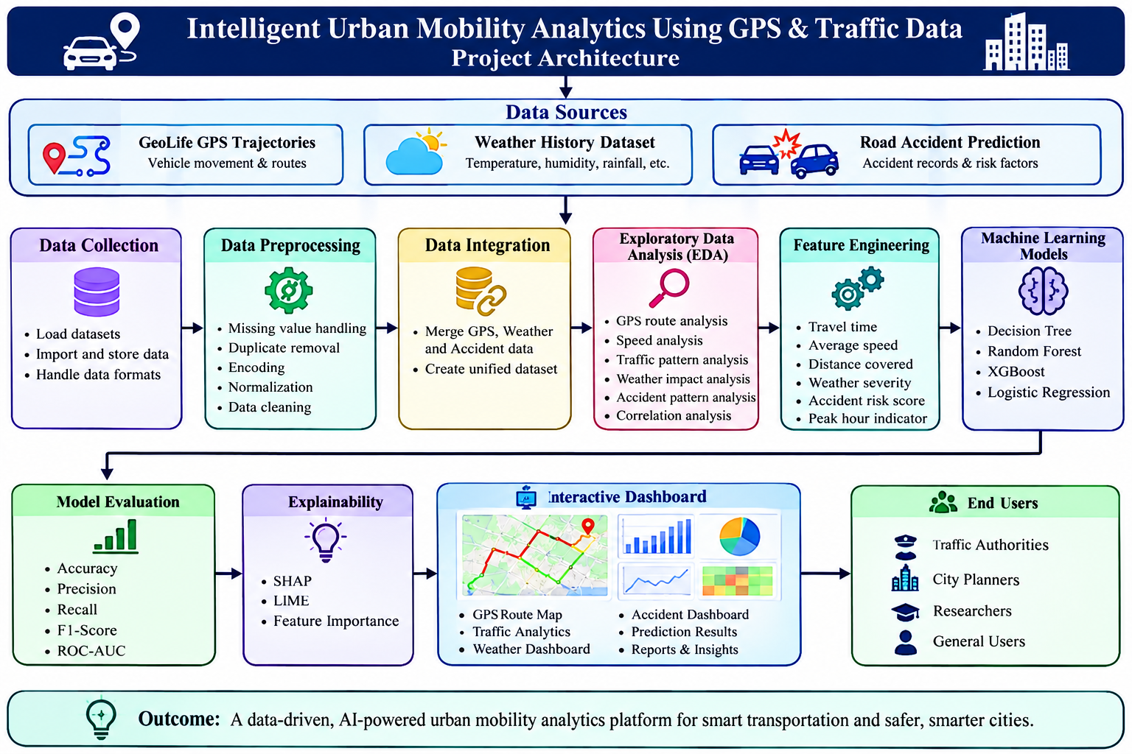

BATCH NO – 07
Team members
2420030066 - P.Likhith
2420030225 – Sanivarapu Sadhana
2420030336 - M.Pavani Sree

